- I have enabled MFA through google authenticator for an investor account. It requires me to enter the code in the website when I try to login, but it does not asks for any code on mobile app. Lipan.dutta+401@gmail.com/123456789!
- Portfolio: not showing active and matured investment plans.
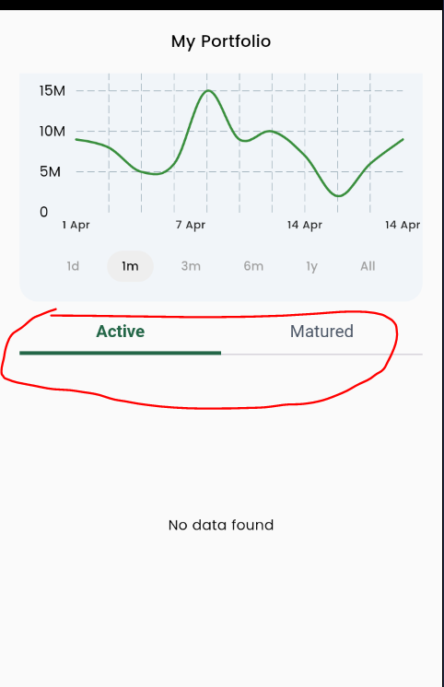

- Wallet: not showing recent transactions.
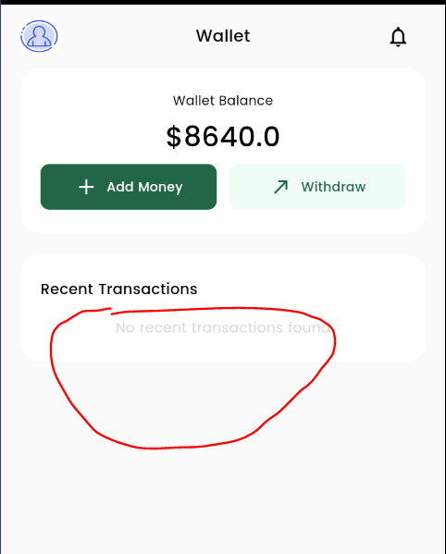

- Both web and app: there is no option to upload profile picture. We need this option.
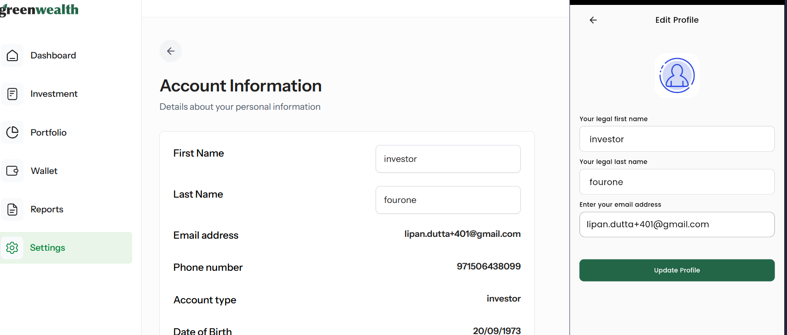

- Profile:
  - Need to show other information that are uploaded while creating the account, same as web.
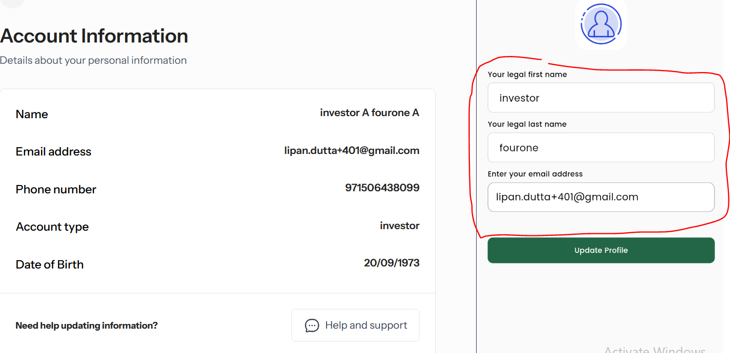

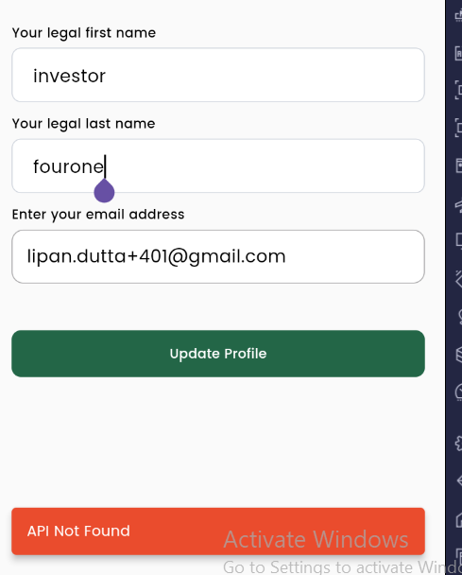
  - Profile update does not working. showing an error.

- Bank account: currently it does not require PIN. We need to update it. PIN is a must to add bank account info.
- Created support ticket from mobile app and got a success message. But cannot see the ticket on zoho desk.
  - I have tried from web as well and still cannot see it in zoho.
- Referral:
  - Share option not working.
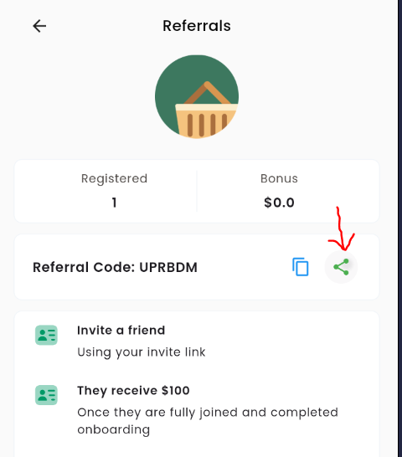

  - Back button does not work.
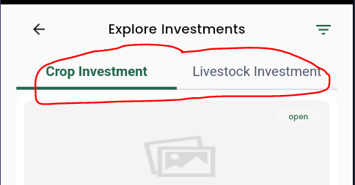
- Investment plan list page: filter does not work. All investment plan shows in both tabs.

- Investment plan detail page: some data are static.
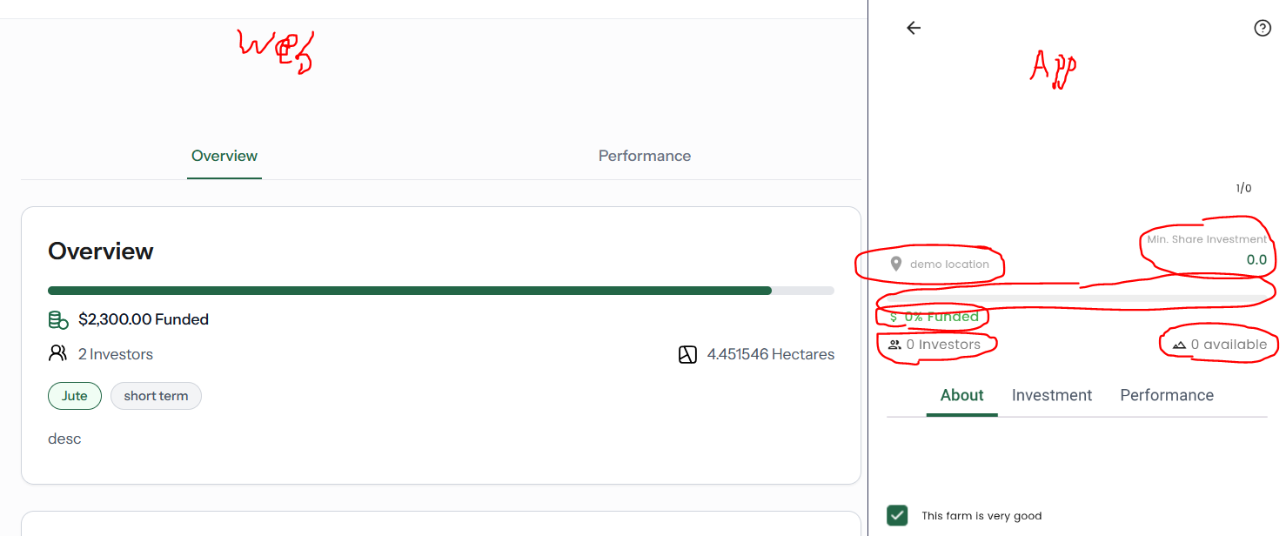

- Unable to buy investment plan. The page is broken.


- Investment detail page:
  - Need to update investment detail info.
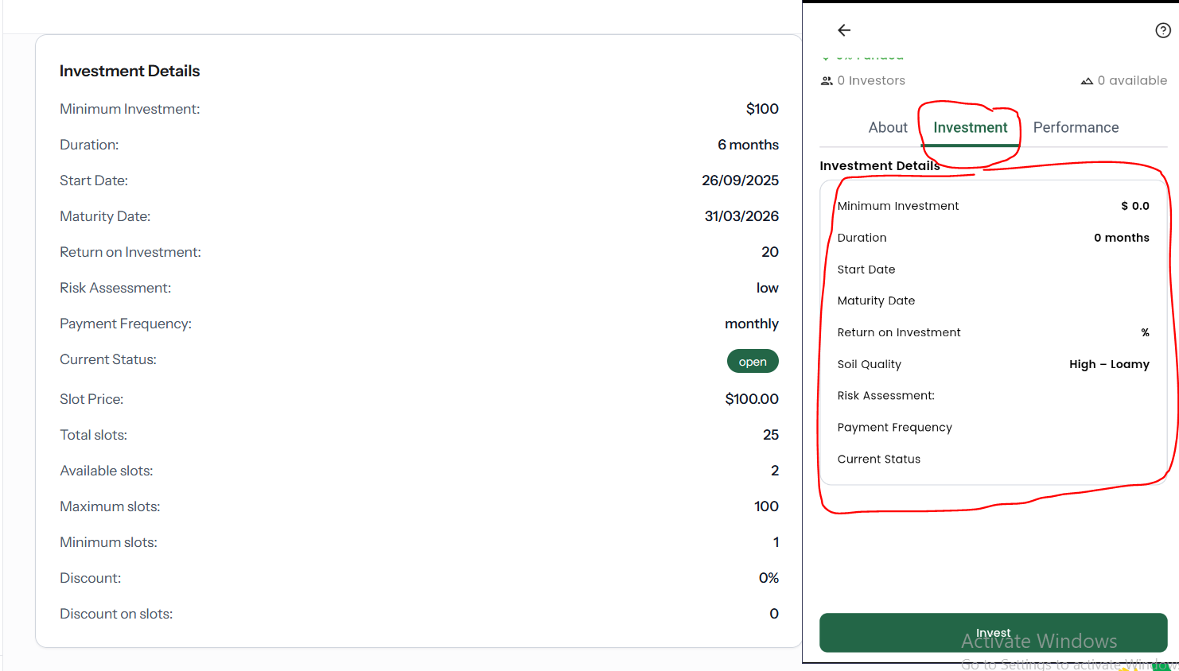

  - Need to show following:
    - Why invest
    - Investment cycle
    - Activities
    - Investment calculator
- Wallet/add fund/bank transfer:
  - Bank account is static. Need to show the dynamic bank info uploaded from super admin.
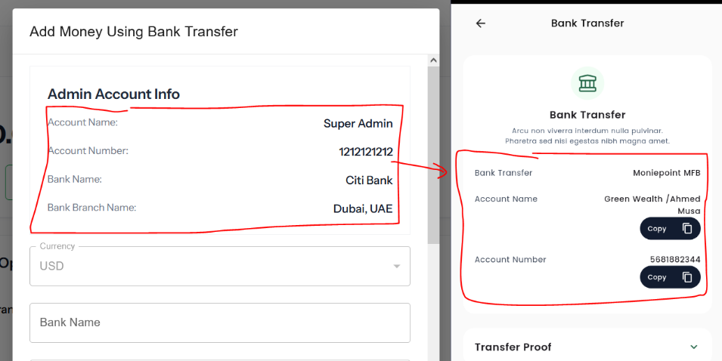

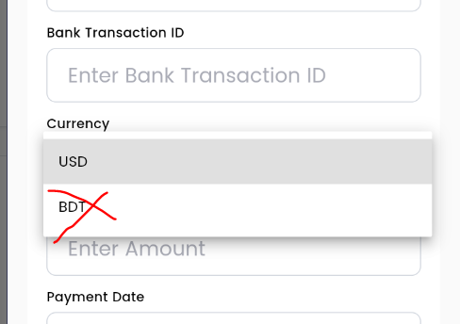
  - Lets remove BDT from currency drop down.

- Wallet: I tried to add fund through card payment. When I entered all info and got success message, then I was redirected to the app and I landed in the login screen.
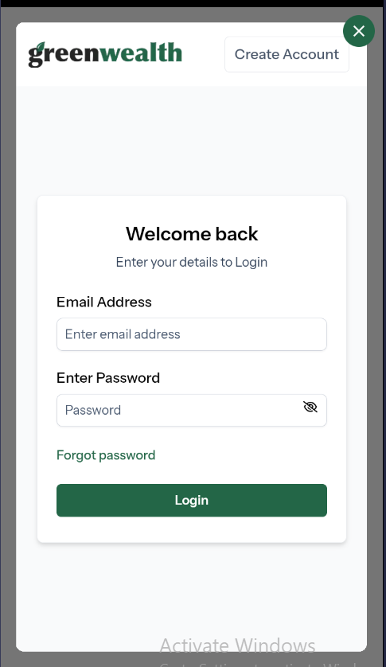

- Fund withdraw:
  - Submitted fund withdraw request. It went through as I can see the request in admin panel. But I got an error.
  - Need to implement PIN here.
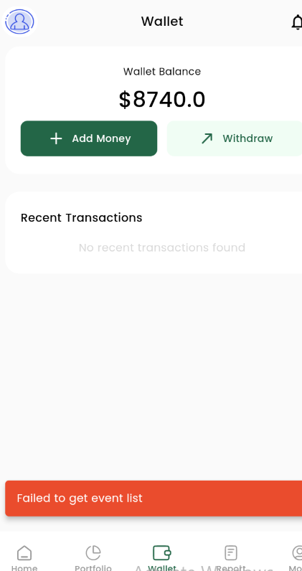

- Multi factor authenticator:
  - Need option to copy the secure ID.
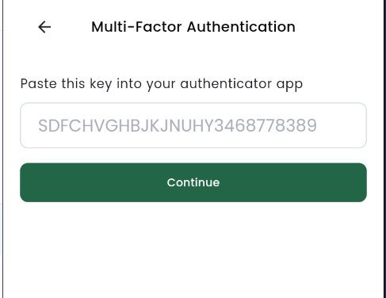
  - Need option to enter OTP (generated after adding the secure ID in the authenticator).

